***Historical tour in Schiedam***

**Start from Schiedam ** VVV-kantoor

Make groups and then go ! « Les renards »  decide which group has done the best job !

|  |
| --- |
| **Respect a few rules**  1. Stick together. Don’t stay behind or you won’t have enough time to do everything. It has to be « flitsend om het leuk te houden »  2. Don’t go with groups you might come across. Walk past them and go your own way. Don’t cheat and copy the other groups’ answers! Remember, you are opponents! There will be « policerenards » who will keep an eye on you.  3. You have to walk to all the places where the « renards »will be. Make a good impression to them because they will assess you and give you a mark (=grade).  4. In each group, there will be a person in charge who will give the exercises at the end of the tour. (Because it may be cold, the quiz can be completed in turns.)  5. Needless to say, you have to behave yourselves when in town. Don’t approach people just for fun ! The “renards” will be watching you again.  6. It is forbidden to go shopping. Don’t buy any chips, drinks, etc,because you will have no time for that !  Have fun ! |

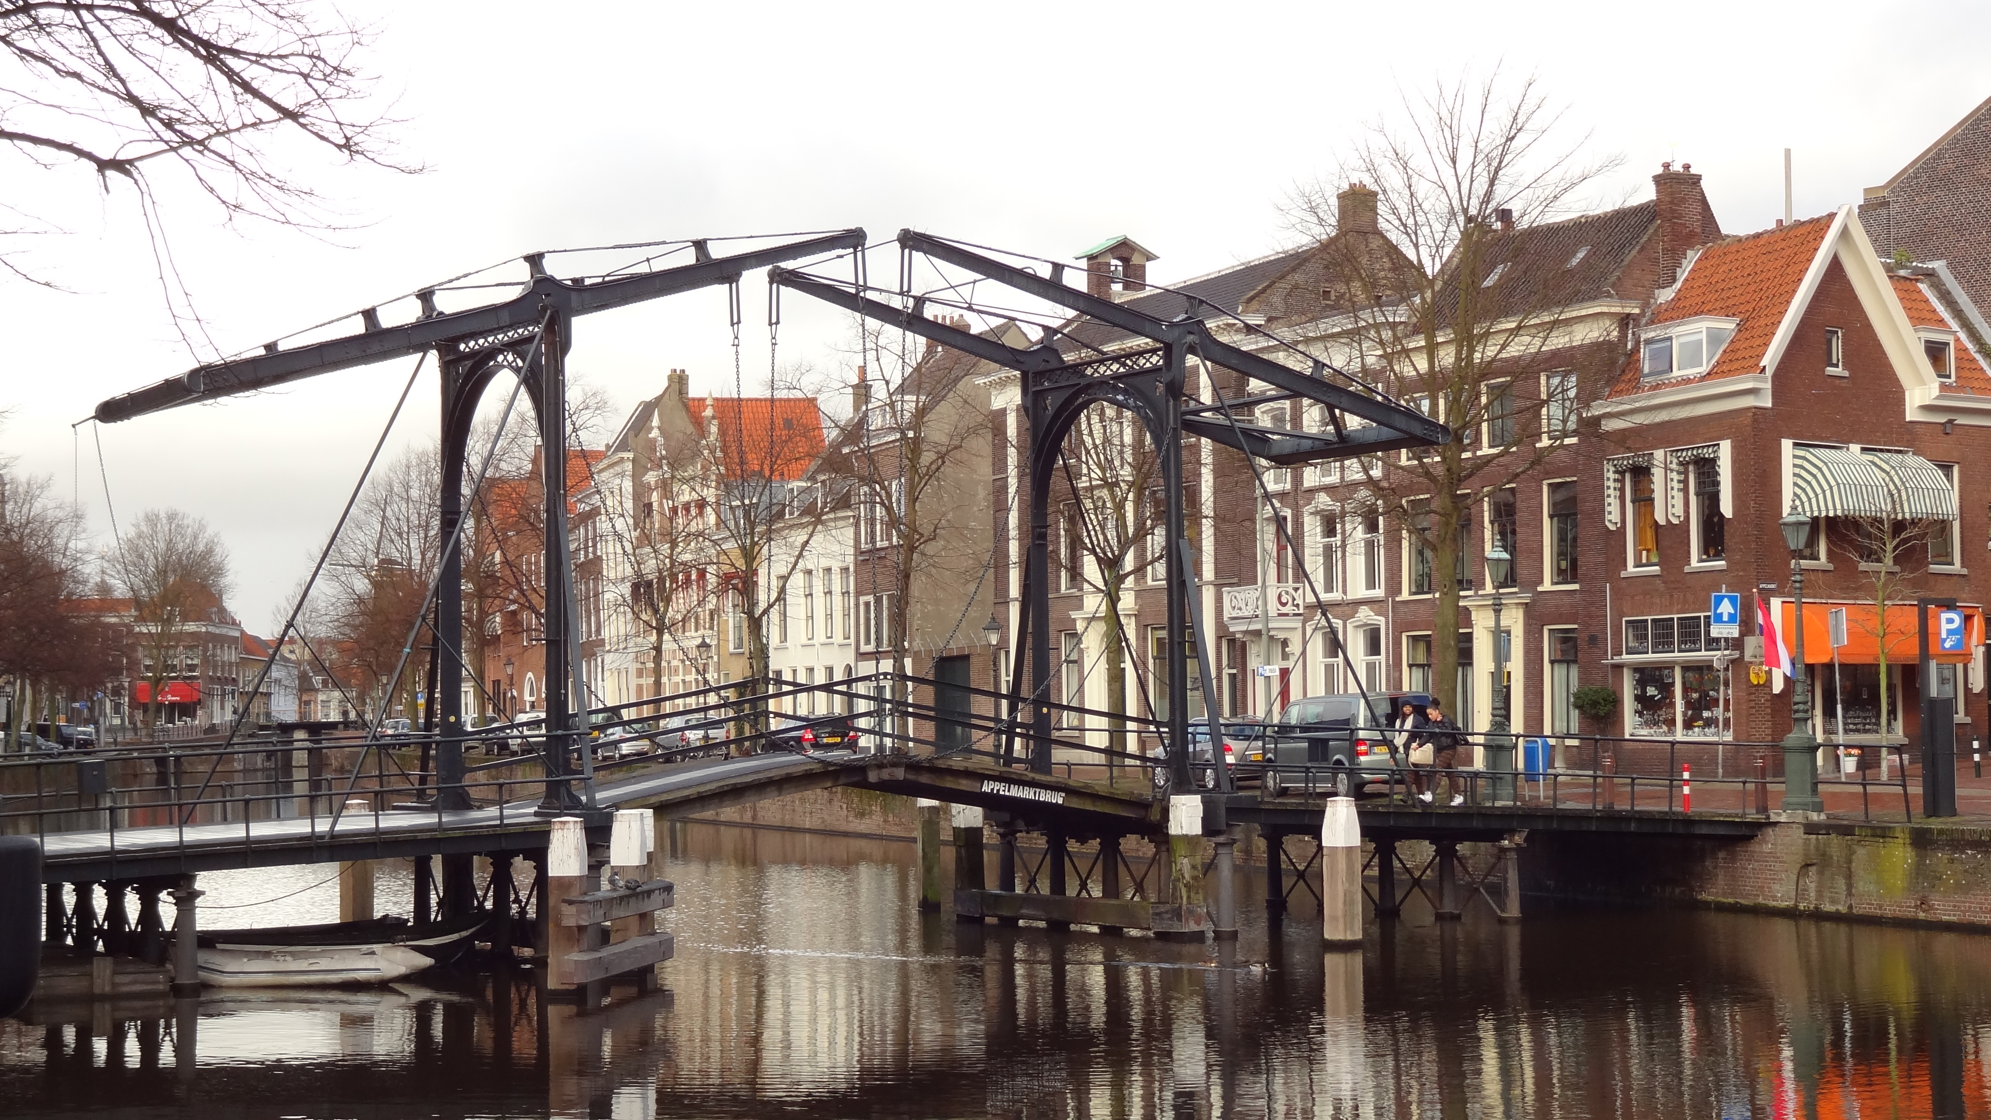

**Group _____________names:**

1.____________________________2.____________________________3.____________________________4.____________________________5.____________________________6.____________________________7.____________________________8.____________________________9.____________________________10.___________________________



Start from the square where the Tourist Information is situated. Walk across the place and turn left.

Turn left just after the bridge and climb up the stairs. This bridge was built in 1927.

Keep on walking along the canal “Lange Haven” which was dug between 1336 and 1339 to make the river “Schie” and the river “Meuse” merge. Schiedam is a dam on the river “Schie”.

**Exercise 1:**  Look for the « Canal renards » and listen to their explanations about how to dig canals at the time. they will ask you one question to make sure you have understood everything. write dow the answers below.

______________________________________________________________________________________________________________________________________________

Walk past beautiful 17th century houses which have 18th or even 19th century frontages. For example : houses number 5 and number7.

**No. 25:** Look for the “Frontage renards ». This house with a ‘clock frontage’ is classified as a historic monument (National Heritage).

**Exercise** **2:** Many houses have either a frontage with a clock or a frontage with stairs.

Draw each type of frontage and show your drawing to the “renards”.

|  |  |
| --- | --- |
| ‘Clock frontage’ | ‘Stairs frontage’ |
|  |  |

Walk on to number 65. This house belonged to rich people. It was built in 1804. Above the door, you can see the head of the Roman god Mercury, the patron god of trade.

**EXERCISE 3:**

Cherchez les "**renards Dieux"** et répondez à leurs questions. _______________________________________________________________________

_______________________________________________________________________

Keep walking and look for the « renards photos ». Below, you can see a beautiful photo of the canal, the mill and the houses.

|  |
| --- |
|  |

**EXERCISE 4**: Try to take the same photo.

Here is the mark (=grade) given by the “renards”.

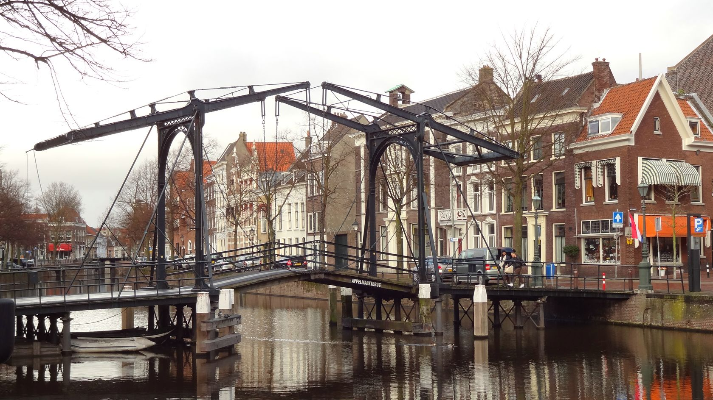

Look opposite and you will see the church of the port. It used to be a Catholic church with a beautiful porch and Toscani Italian pillars. in this church, there was an eye which could see everything. « Beware, dear children from Schiedam, the eye is watching you… » Many children did not sleep because of him.

Walk on to Appelmarktbrug (the bridge of the apple market). It is one of the three iron bridges which were built around 1830. It is one of the oldest draw bridges in Holland. When a boat needs to pass through, the bridge is hand-lifted by two bridgemen.

**EXERCISE 5:** Look for the "Bridge renards" and answer the following question :

What makes this Appelmarktbrug (=the bridge of the apple market) so very special ? (Read carefully the explanations above). Show your answer to the « renards ».

______________________________________________________________________________________________________________________________________________

At the “Vismarkt” (fish market), turn left in « Walvisstraat » (whale street).  
Walk to the windmill. It is called :

__________________________________________________________________

On the night of 14/15 February  1996, this windmill was destroyed by a big fire. The renovation and restoration of the place was complete in 1999. Inside, there is a shop which sells flour and other produces having to do with the making of bread.

**EXERCISE 6:**

Look for the “Windmill Renards” and listen to their stories on the history of the windmills in Holland. They will ask you a question to make sure you have understood everything properly. write down the answer below :

______________________________________________________________________________________________________________________________________________

|  |
| --- |
|  |

Take the pose and imitate a windmill with your bodies, then take a picture of it. Keep your photo. The “renards” will give you a grade (=mark) for your work :

Walk back to the canal and turn left.

**EXERCISE 7:** 150 metres further, on the other side of the canal, just in front of you, you will see house number **112** across the canal(opposite house number **123** on THIS side) whose name is « the market ».  
Why is THIS building in perfect harmony with the oldest buildings around. (For example, look at the building to your left)

______________________________________________________________________________________________________________________________________________

**House number134**: it was the renowned poet **François Haverschmidt**’s house, best known as **Piet Paaltjens (Pierre Poteaux).** He lived there from 1864 until his death in 1894. Look through the window.   
  
Walk across the bridge, then look right and you will see his statue.

**EXERCISE 8:** Look for the “poet renards”. Write a short poem of 4 lines and name your favourite poem infront of the judge. Do it quickly.

The « renards » will give you a grade (=mark) for your work :

(If you make a video of your work, you will gain (accumulate) more points.)

|  |  |
| --- | --- |
| Originalité: | Performance: |
|  |  |

**De Korenbeurs**: (the grain stock exchange) It was build between 1787 and 1792 by Giudici the architect and it was adapted by Rutger van Bol’Es the Schiedam architect. You can see Neptune and Mercury, respectively the gods of the sea and of trade.

At the stock exchange, all kinds of wine and grains were sold. The « Korenbeurs » had to close down in 1918 because the alcohol made from corn, rye and barley was getting too expensive. It was cheaper to produce alcohol from beetroot.

The bridge you can see on your right dates from 1903. When you stand on the bridge, you can see the doors of the lock.

**EXERCISE 9:** What is the use of a lock ?

______________________________________________________________________________________________________________________________________________

Walk by Hans van der Plas’s sculpture of « Zakkendrager » (men who carried bags) which

is a symbol of the workers. Each man would have a nickname.

Follow the right-turn. You are now in the oldest part of Schiedam, the old lock.

Lady Aleida van Henegouwen had a dam on river Schie built. Thus, out of the marshes was born a new colony called Schiedam. It grew into an official town in 1275 .

Keep walking to the “zakkendragershuisje” (huis=house) next to café Sjiek [chic] and look for the « Porter renards » carrying bags.

**EXERCISE 10:** What is the origin of the name of the city Schiedam ? What did it take its name after ?  
Give your answer to the «  renards » and write it down. You have to read very carefully what is above.

______________________________________________________________________________________________________________________________________________

**House number 94 :** This is a restored brewery. In the frontage you can see a stone on which a French fleur-de- lys is engraved. It is the symbol of Virgin Mary and so of virginity.



A lot of buildings were used as distilleries. The wives of the workers were allowed to fetch some hot water for the washing and the cleaning. Sometimes, they would open the wrong tap and they took some wine instead. No one could believe they were about to wash the floor with that !

**Number 84 :** There is a 17th century house just before the bridge. It is the only house with a mezzanine in Schiedam.

**EXERCISE 11:** Look for the "House Renards " and show them the answers to the two questions below.

-In your opinion what is a mezzanine?

__________________________________________________________

-Face the house and look for Roman numerals. What year is **MDXCVI**?____________

_________________________________________________________________

When you reach the bridge, turn right twice to go to "Grote markt"(big market).

Now you are at the Town hall which was built in a Gothic style in the 16th century with elements of the Renaissance.

In 1782, a new frontage was built around the old one. In 1718, they completed the landing with the double flight of stairs. Above the door, you can see the emblem with the three hourglasses. The emblem was even used on fishnets. Currently, the townhall is only used for meetings and weddings.

**EXERCISE 12:** Look for the "Renards” of the Town hall by the stairs.

Stand on the steps and give your camera or mobile to one of the “renards” so that he may take a photo of you. **It has to be a ‘special’ photo ; it has to be out of the ordinary.**

Keep going to “Renards-witches in the “Grote Markt.

**EXERCISE 13:** Listen to the story about the witches of Schiedam. You will be asked questions to make sure you have understood everything . Write down your answer below.

_______________________________________________________________________

_______________________________________________________________________

Head towards Sint Janskerk (Saint Jean church). The big tower was built from 1262 whereas the church was only completed in 1500.

**EXERCISE 14:** Look for the “Graves renards”. (outside door no. 37). Listen to their explanations. Write down the answer.

__________________________________________________________________

Walk straight to **"Stadserf"**and turn left in **"Broersveld”**, a busy street**.** Follow the tourist information (VVV-kantoor) signs and then go back to your starting point.

**No shopping !!**

**The scores**

|  |  |  |  |  |  |  |  |  |  |  |  |  |  |  |  |  |
| --- | --- | --- | --- | --- | --- | --- | --- | --- | --- | --- | --- | --- | --- | --- | --- | --- |
|  |  |  |  |  |  |  |  |  |  |  |  |  |  |  |  |  |

|  |
| --- |
|  |