**Voici les instructions pour rédiger et illustrer votre journal de bord.**

* Vous pouvez tout **refaire** à l’aide d’un **ordinateur** et y insérer vos *réponses* ainsi que vos *commentaires personnels* et *documents collectés* sur place. (le document sera disponible sur le site du collège.)
* Vous pouvez aussi découper PROPREMENT et coller les documents ci-dessous et y ajouter votre *travail* et vos *documents* dans **un cahier**.

**1- My journey**

* 1. **The itinerary**



1. **Place on the map**

* the following countries : *France, Belgium and the Netherlands*

the following towns or cities : *Pont l’Abbé, Rennes, Paris, Lille , Schiedam,*

*+ two Belgian cities we passed on our way to Schiedam*

* Do not forget to circle : *Brittany*, *Finistère, the Netherlands and Holland*.



1. **Draw the itinerary with a** red **pen.**

|  |
| --- |
|  |

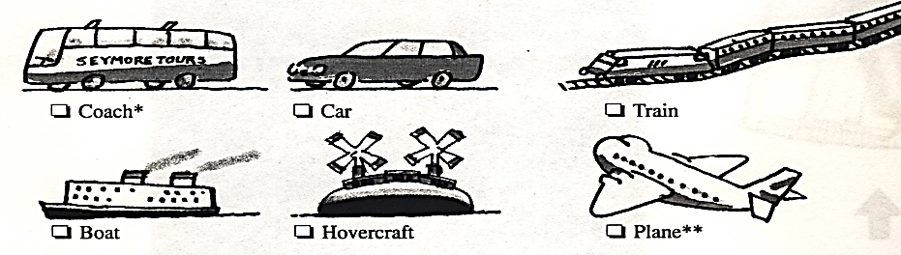

* **Tick** the right box(es)

**1.2 The means of transport**

**1.3 The journey on the coach**

|  |  |
| --- | --- |
| **QUESTIONS ABOUT THE JOURNEY** | **YOUR PERSONAL ANSWERS** |
| Name of the coach company |  |
| Name of the coach driver |  |
| What time did we leave Pont l’Abbé ? |  |
| What was the weather like ? |  |
| How did you feel ? |  |
| What did you do ? |  |
| How long did it take to go from Pont l’Abbé to Schiedam ? |  |
| What time did we arrive in Schiedam ? |  |
| How did you feel ? |  |
| What did you do when you arrived ? |  |

**2- My first impressions**

What did you first notice about cars (number plates), houses, buildings, roads, road signs, traffic lights, shops… ?

**3- The family**

**Ask questions to the family. That will be a good opportunity to chat with them !**

**3.1 The members of the family**

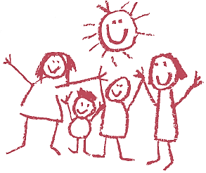

**Take a of them and present them !**

**Who are they ?**

How old are they ?

What are their names ?

How many children have they got ?

**photo**

Their jobs ?

Have they got any pets ?

What are their hobbies ? What do they like ?

What are they like ? (their personality)

***“Travel broadens the mind.”* = les voyages forment la jeunesse**

* What are the similarities and the differences between the Dutch and the French ways of life and cultures?

**travel = voyager**

**broaden = élargir**

**the mind = l’esprit**

* Compare …. food, architecture, etc.

|  |  |
| --- | --- |
| **3.2 Location** :   * Where do they live ? **Circle** the place where you are living.. * What is their address ? * **Locate the place on the maps.** |  |

**3.3 Accommodation**

* How long have the family lived there ?

**a-“ Home, sweet home ! “**

* **Circle** their type of home on the document below.
* **Describe** the house. Take **photos.** Say how many rooms, bathrooms, toilets, etc, there are.



**b-My bedroom** Are you alone (=*seul*) or do you share (=*partager*) it with someone ? **If so, who** sleeps in your room ?

* Draw the **plan** of your room. Place the furniture*, etc and write the name of everything you draw.

Use the **symbols** below. Did you **like** your bedroom ? Why (not) ? *=*meubles*

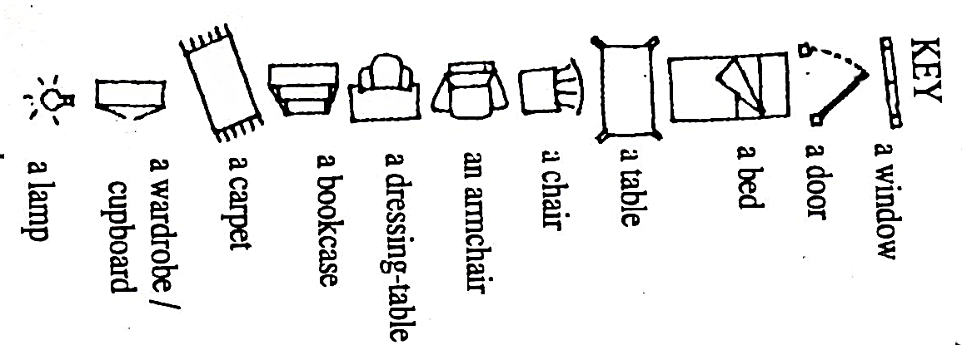

**Food in the Netherlands is different from the food you are used to eating at home ! What did you like and what didn’t you like ?**

**3.4 Food**

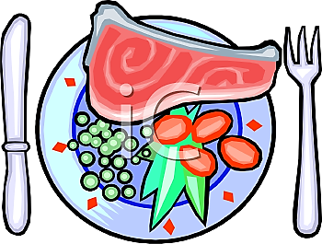

|  |  |  |  |  |
| --- | --- | --- | --- | --- |
|  | **BREAKFAST** | **(PACKED) LUNCH** | **DINNER** | |
| **DAY 1**  **Sunday, 19th** |  |  |  | |
| **DAY 2**  **Monday, 20th** |  |  | |  |
| **DAY 3**  **Tuesday, 21st** |  |  | |  |
| **DAY 4**  **Wednesday, 22nd** |  |  | |  |
| **DAY 5**  **Thursday, 23rd** |  |  | |  |
| **DAY 6**  **Friday, 24th** |  |  | |  |
| **DAY 6**  **Saturday, 25th** |  |  | |  |

**4- Schiedam (QUIZ)**

**5- The places we have visited. (monuments and museums)**

Do not forget to take **photos,** **brochures** and **leaflets** so as to **illustrate** your diary !!!

**a-Present in 4 sentences the 3 largest cities in the Netherlands :**

Amsterdam, Rotterdam, The Hague Its Dutch name ? Its French name ? Its English name ?

**O**n this map of the Netherlands, **place with dots** the cities we have been to.

POLITICAL or HISTORICAL ROLE ?

LOCATION (Where is it situated ?)

POPULATION (Number of inhabitants and their origin ?)

SURFACE (In square kilometres)

**Circle** the places we have been to.

**b-Where have we been ?**

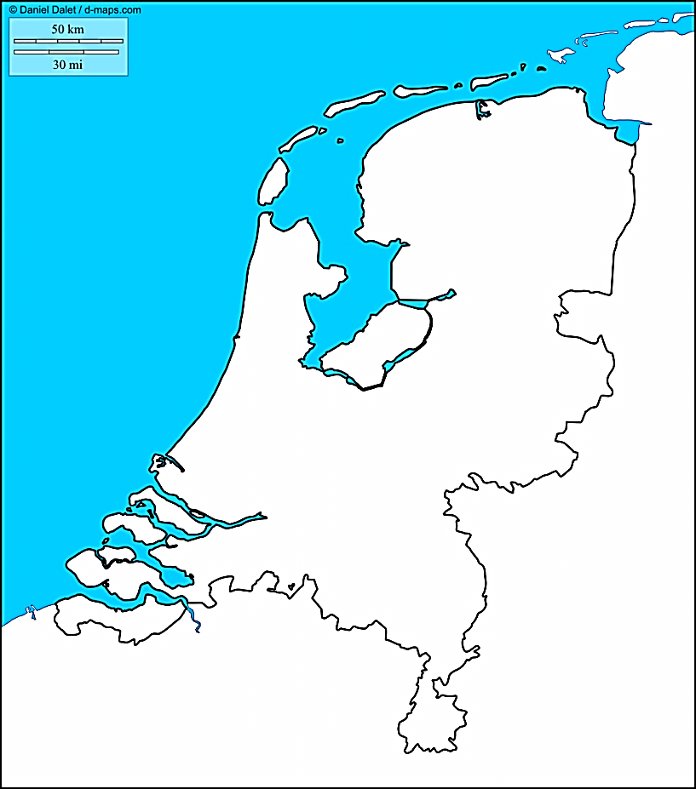[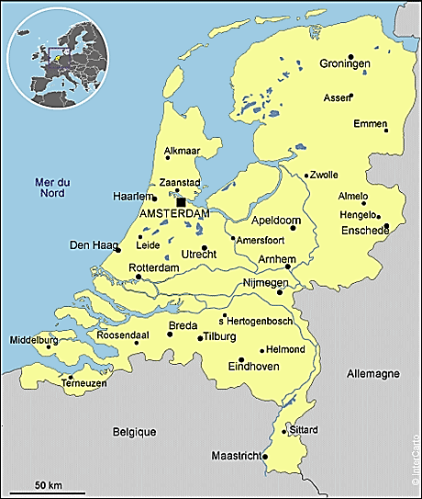](http://www.google.com/url?sa=i&rct=j&q=&esrc=s&frm=1&source=images&cd=&cad=rja&docid=Au8fSbWvAHqpcM&tbnid=b5eAwBhXzP46_M:&ved=0CAUQjRw&url=http://www.dordogne-perigord-export.com/fr/fiches-pays/pays-bas/carte&ei=eGGBUvLGLui00QW5jYCICg&bvm=bv.56146854,d.d2k&psig=AFQjCNFvEhlYLRYonpoAdadCjaGqslSR-A&ust=1384297201812245)

**6-Going back home.**

Tell me about your journey back home. How long ? Where ? Fun ? Who ? What ? Your feelings…

**7-Conclusion** Place(s) you liked best ? What did you like or not ? Did you enjoy the trip ? Why ?